Les Couleurs
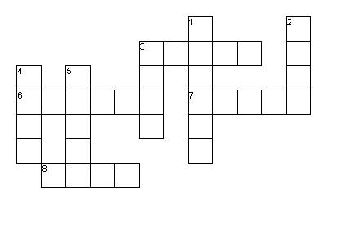
Across Down
3. white 1. brown
6. orange 2. pink
7. red 3. blue
8. green 4. black
5. yellow

Les Couleurs
Across Down
3. white 1. brown
6. orange 2. pink
7. red 3. blue
8. green 4. black
5. yellow

